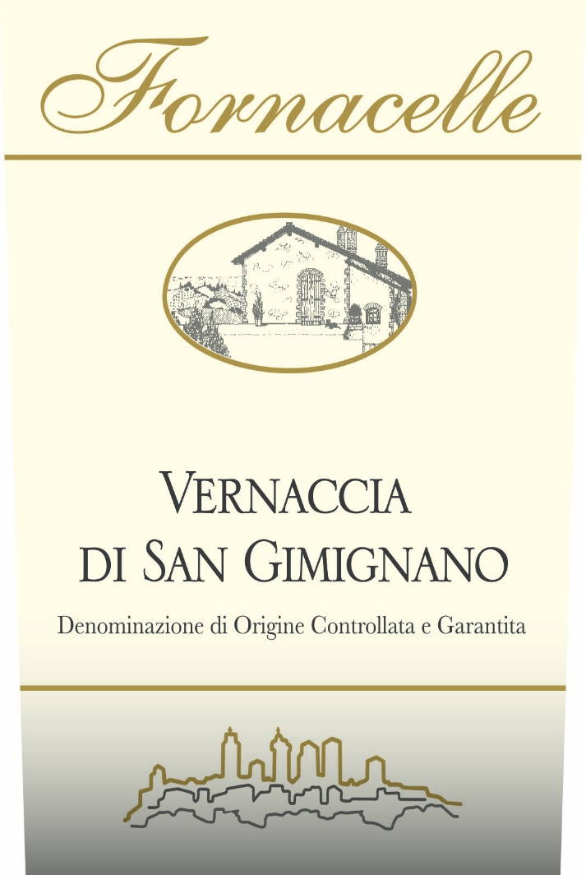
Grapes: 100% Vernaccia
Altitude: 290m. a.s.l.
Soil: calcareous/ clay
Bottle produced: 5,000

Vinification and refinement
The wine-making process in "white" follows the traditional style with a gentle pressing and low temperature in order to keep its exceptional fragrance. The fermentation, at a controlled temperature, has a medium duration of 12 to 18 days in either cement or steel vats. Organic Certified.

Wine description
Color: Delicate straw yellow tending to a warm golden color with ageing.
Bouquet: Characteristic bouquet, elegant and persistent.
Taste: Dry, and harmonious with a slight almond finish.

Food pairings
Excellent aperitif, it is delicious with fish, shellfish and vegetables. Serve at 10°C.

